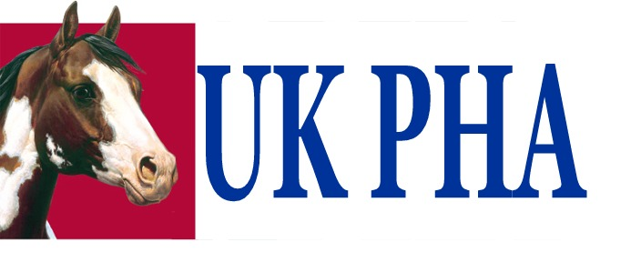

UK Paint Horse Association

Membership Application Form

Please print clearly and provide complete information

Name (if family membership please list all names):

_______________________________________________________________________

First line of Address: ________________________________________________________________________

Second line of Address: ________________________________________________________________________

Town: ________________________________ County: ____________________________________

Post Code: ______________________ Country: __________________________________

Telephone/ Mobile: ________________________________

E-mail: _____________________________ Website address: www. ______________________________

Number of Paint Horses Owned:

Pure Breds: ………
Part Breds: ………

Please attach a copy of your Paint Horse registration papers and return to UK PHA via post or email.

What area of riding are you interested in:

- Western riding generally
- Western competitions
- English riding
- English competitions
- Hacking
- Other (please specify):

What events you would like to attend:

- Competitions (Western/English)
- Clinics
- Camping weekends & trail riding
- Social meeting within your area/ nationally

What level of riding would you describe yourself as:

- Happy Hacker

- Novice

- Advanced

- Professional

Membership Level – please tick appropriate box

□ Adult £25
□ Family (2 Adults + 2 Under 18’s) £45
□ Junior/ Youth (under 18’s) £ FREE Date of Birth: _________________
□ International (outside UK) as above, plus an additional £10

Payment Due £__________ Please make payment via:

PayPal: ukpha.treasurer@gmail.com

Cheque payable to - UK Paint Horse Association

Bank Transfer: Natwest
Name on account: UK Paint Horse Association
Sort code: 52-30-31
Account # : 498 47 953

Signed: __________________________________ Dated: / /

Are you APHA member?

- Yes
- No
- No, but I would like to receive more information
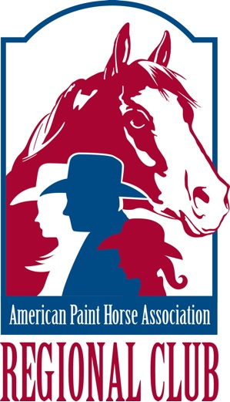
Are you registered with PAC?

- Yes
- No
- No, but I would like to receive more information

Please return completed form and payment to:
(post or emai)

Secretary

UK Paint Horse Association

8 Fernhills Road, Hythe, Southampton, Hampshire, SO45 3HE

Email: ukpha.secretary@gmail.co.uk

